## horizontal line



Cafe

HQCMS

**───**

# 

# Table Content

Installation

Login

Employee Management

Roles and permissions

Cafe Management

Visitor Management

Inventory Management

Leave Management

Training Management

Report Management

# 

# Installation

### **Check whether IIS, nodejs and mysql installed on the server.**

We can check this in start menu by searching,

* iis (or) inetmgr
* Mysql
* Nodejs

If it is not installed, we need to download the softwares and install. For IIS we need to just enable it .

**Enabling IIS :**

go to control panel-> Turn windows features on or off -> Server manager will be prompted. In Add roles and features wizard,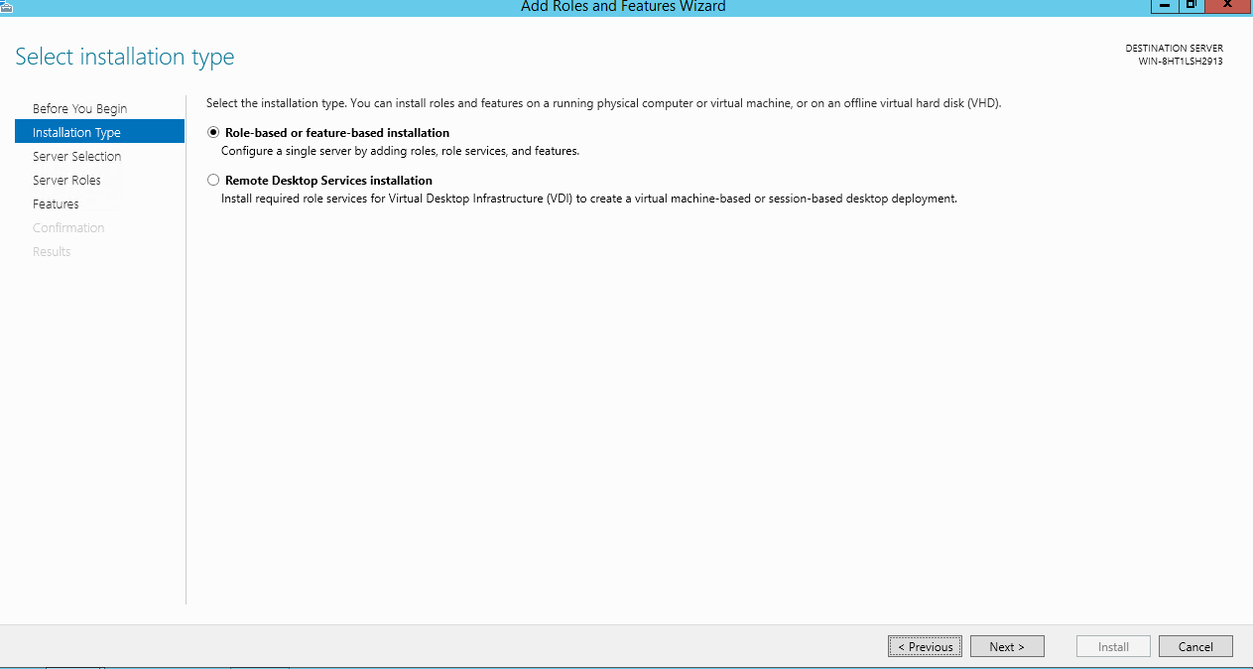

Select the below features and its child features,

* .NET framework 3.5 features
* .NET framework 4.5 features
* Remote server administration tools
* SMTP server
* Windows process activation service

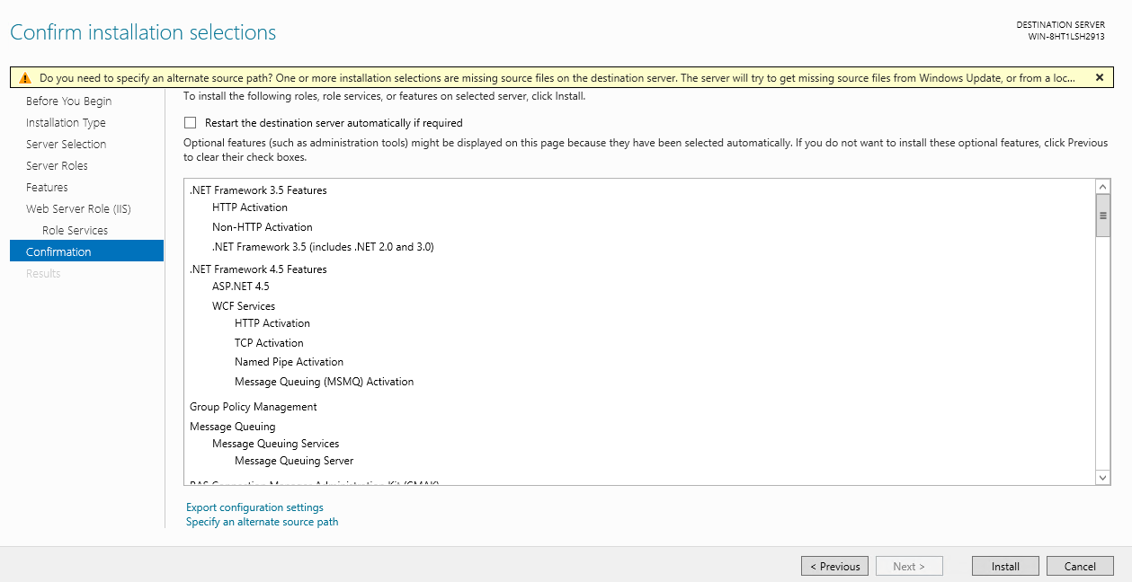

Final step of installation should be like this.

**Installing Mysql :**

Download Mysql 5.7 using the link <https://dev.mysql.com/downloads/windows/installer/5.7.html>

Select ‘Windows (x86, 32-bit), MSI Installer with 503.8M’ and select ‘No thanks, just start my download.’ in next page. It will start downloading the software.

Once it is downloaded, install it.

Set the root user password now. We need to share the db name and credentials to the developer, so that developer can use it in the code for db connection.

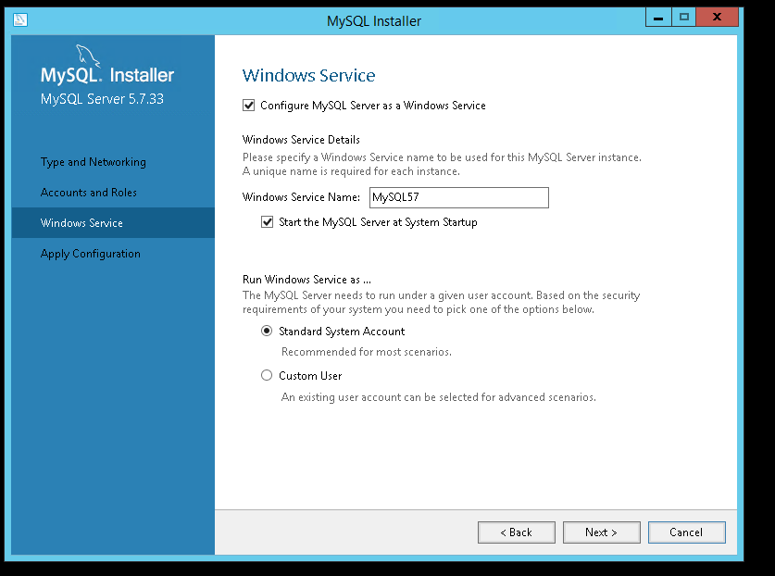

Installation is same like mysql installation. After installation mysql work bench will be launched. We need to create new connection and login with the root credentials.

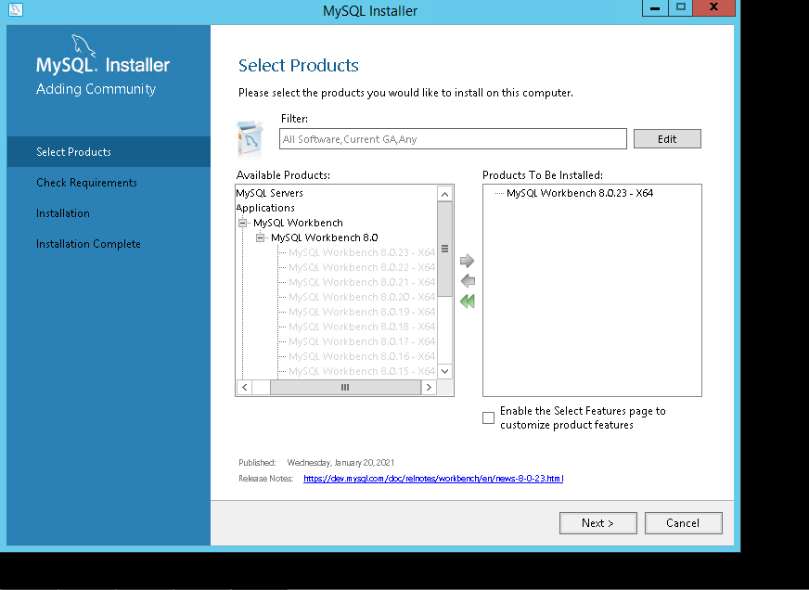

**Installing Node js 12 :**

Download the Node js 12 software from this link, <https://nodejs.org/dist/latest-v12.x/node-v12.21.0-x64.msi>

Install it, with default values in wizard.

We can confirm whether it is installed by searching in start menu.

Executel below commands in command prompt which will install angular, typescript and sails

* npm install -g @angular/cli
* npm i typescript
* npm install -g sails

Create “cms” folder in this path “C:\inetpub\wwwroot\”

Create a folder “cms frontend” inside cms and “dist” folder in cms frontend

Deploy the frontend build (webe folder) given by the developers, inside the “dest” folder .

Create a folder “agile_backend” inside cms folder. Deploy the backend build given by the developer. Folder structure and backend files should be like in below picture,

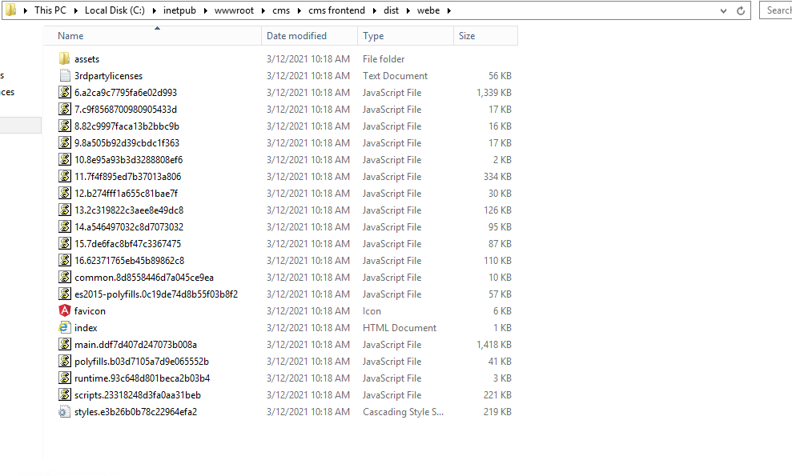

Creating db and deploy sql files in mysql. Open mysql workbench and connect to the mysql server with the root credentials we created.

Create a new schema (db) with the name “agile_production” and click on apply.

Once schema is created select Server -> Data import .

Select option “import from self contained file”. Browse the sql file which is given by developer.

Default target schema should be the schema (db) name “agile_production” which we created earlier and click on start import.

(refer below picture)

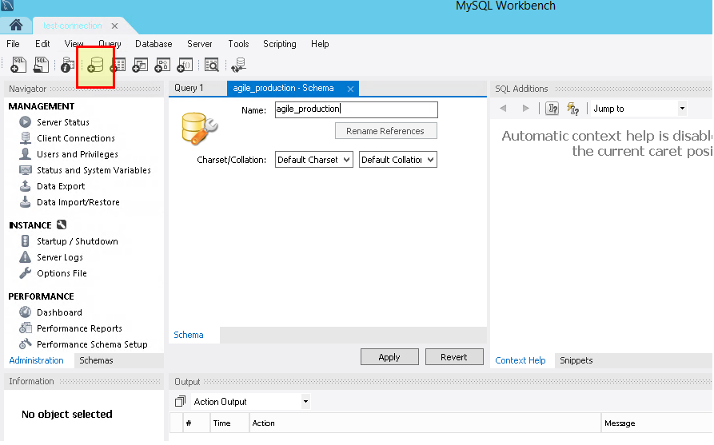

Once import completed we will get “1 of 1 imported”.

Create a new site with the name “cms”, application pools “cms”, physical path should be “C:\inetpub\wwwroot\cms\cms frontend\dist\webe” and port is 81.

Open the chrome browser and hit the <http://localhost:81> url, we should see the

page like below

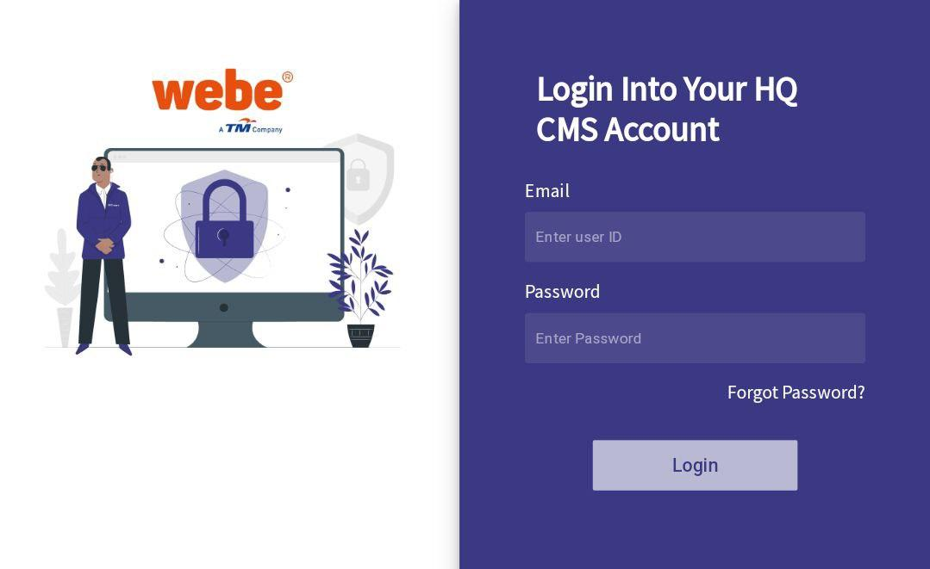

# Login

Before entering the cafe world you might enter with the proper email id and password.

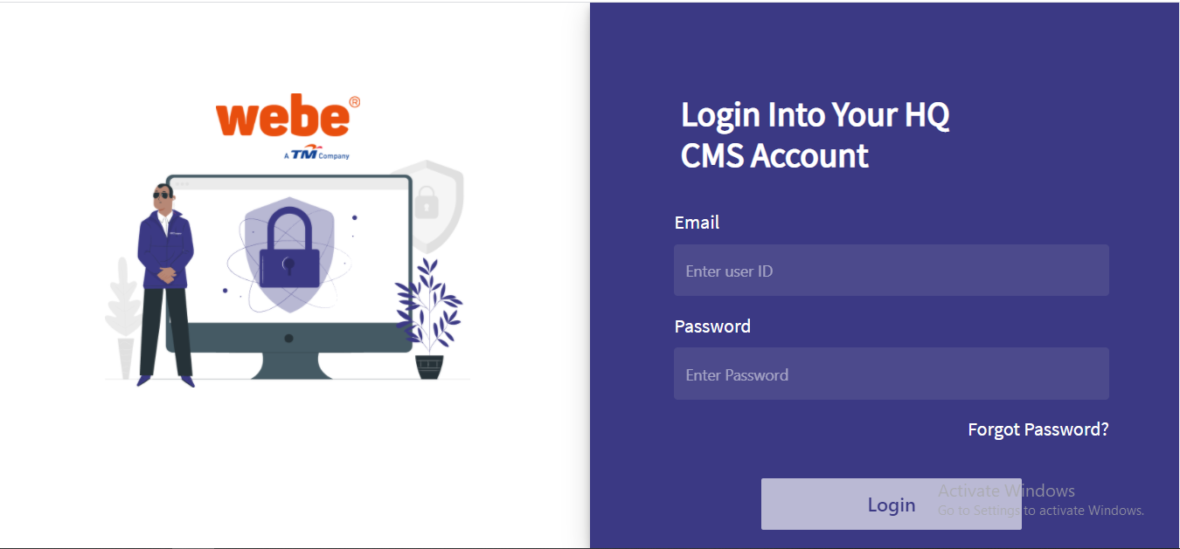

Credentials get success then we redirected to the dashboard.

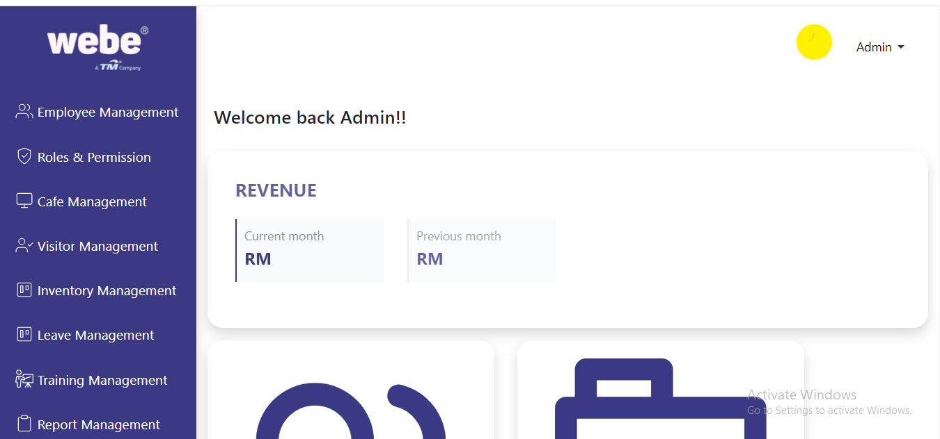

# Employee Management

In the employee management section we can manage employees for all the cafe different locations.

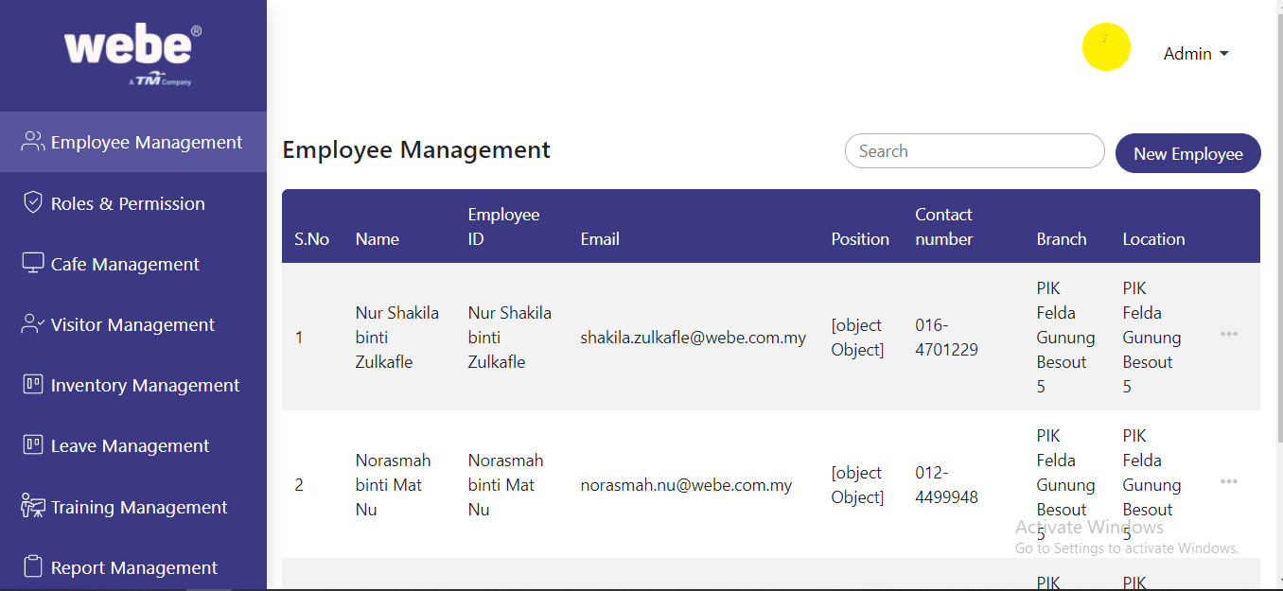

Create a new employee by clicking on the New Employee button and we can edit the employee details by clicking on the three dot button. 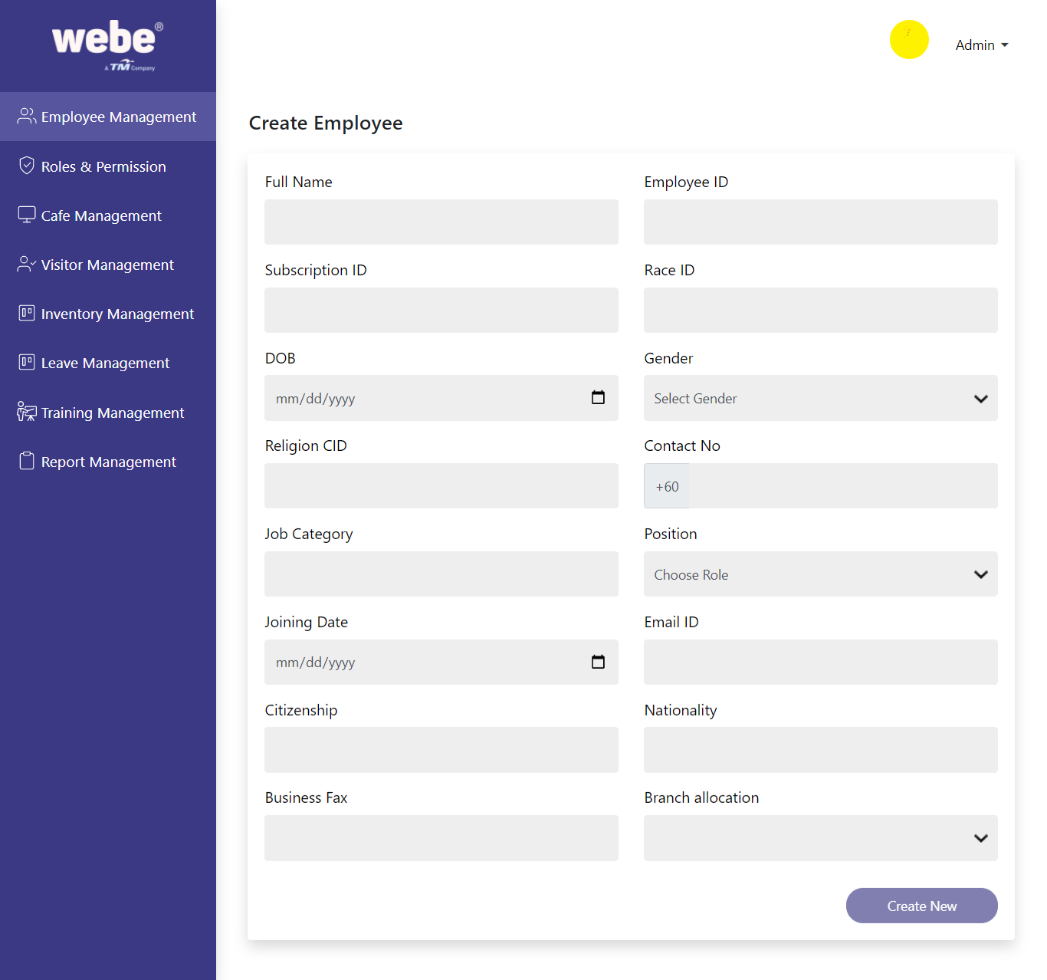

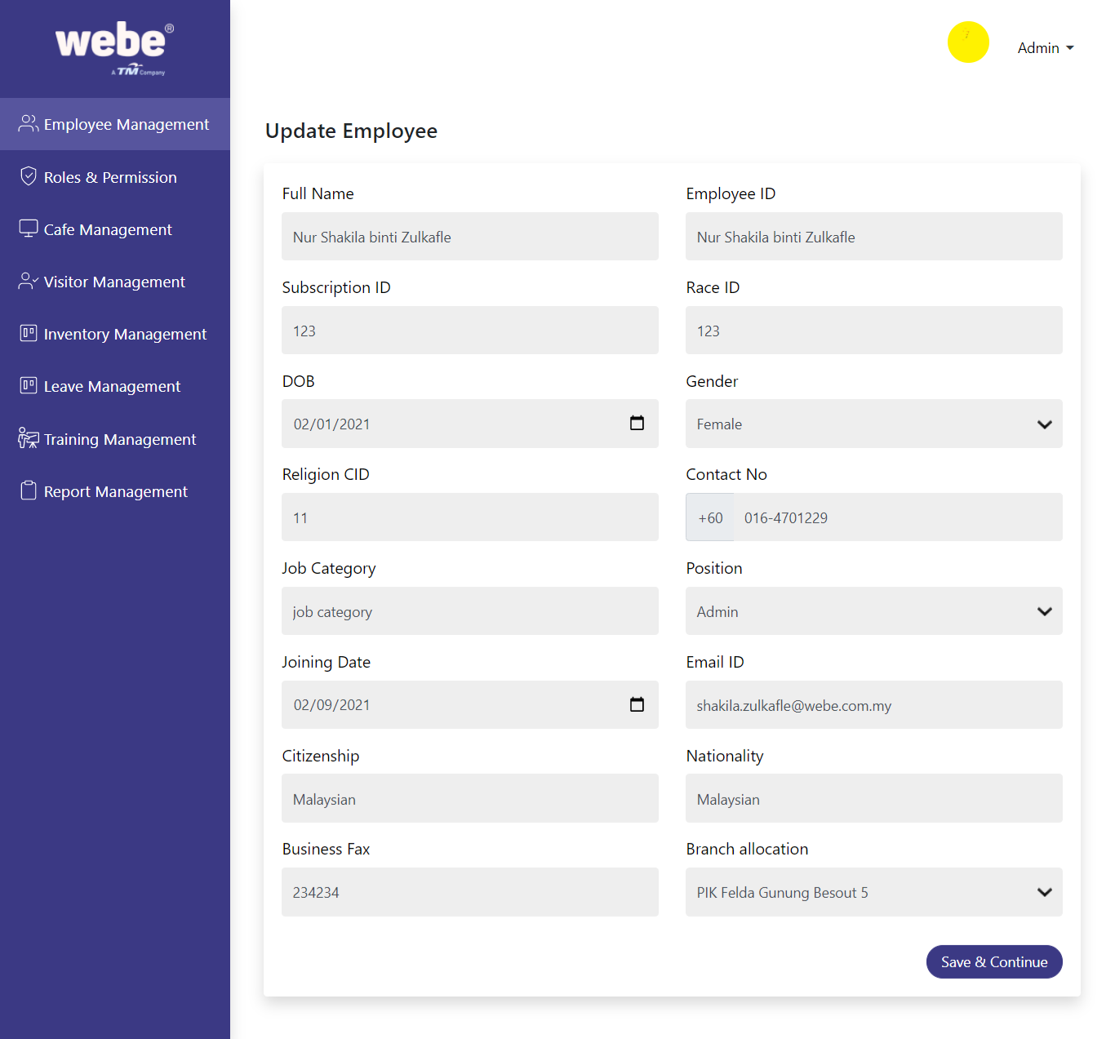

# Roles and permissions

Create a new role by clicking on the Create Role button. You are able to create a new Role in the Role name textbox and by clicking on the checkbox. The selected checkbox permissions will be assigned for the role. The employees under the role can perform with the cms application. We can edit the permissions by clicking on the above three dot button.

# 

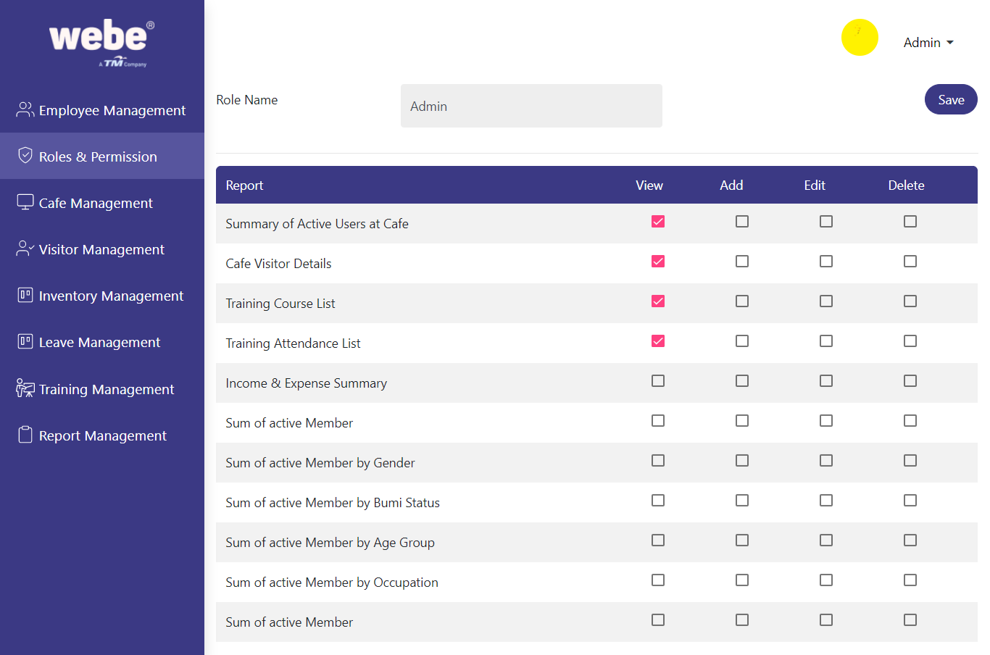

# Cafe Management

We can manage all the cafes in the cafe management section. We can add a new cafe or modify the details in this section. 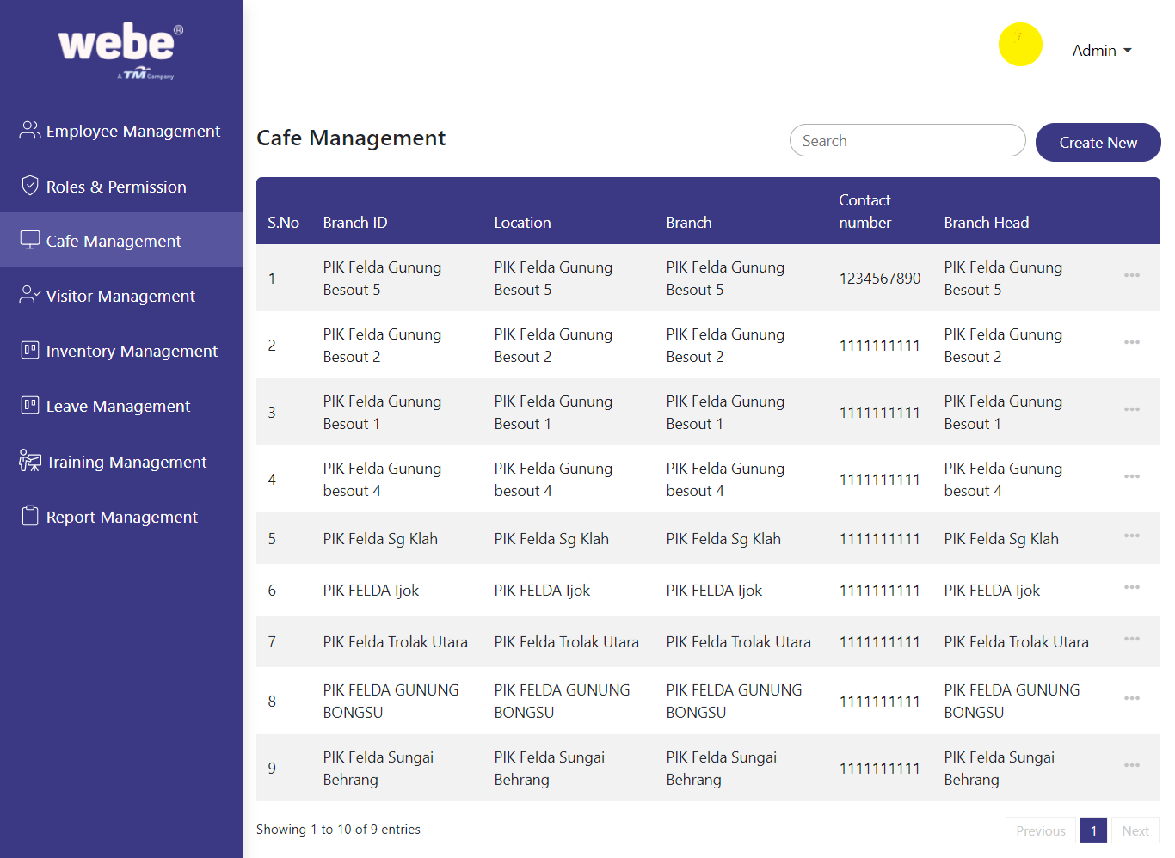

Create a new cafe by clicking on the Create New button and Fill all the mandatory details and create a new cafe branch. Based on the list of the cafe the employees are created and assigned with the roles. Edit the cafe details by clicking the three dot buttons.

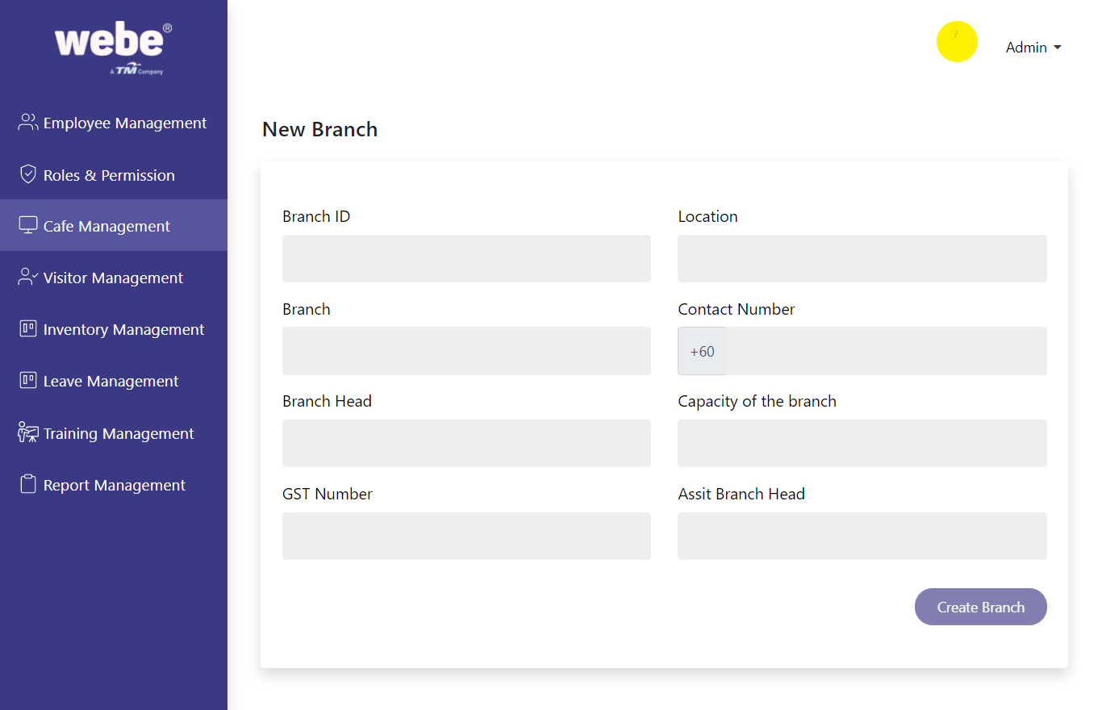

# Visitor Management

We can monitor visitor details and their usage with the cafe by help of creating the visitors in the various cafe branch locations. 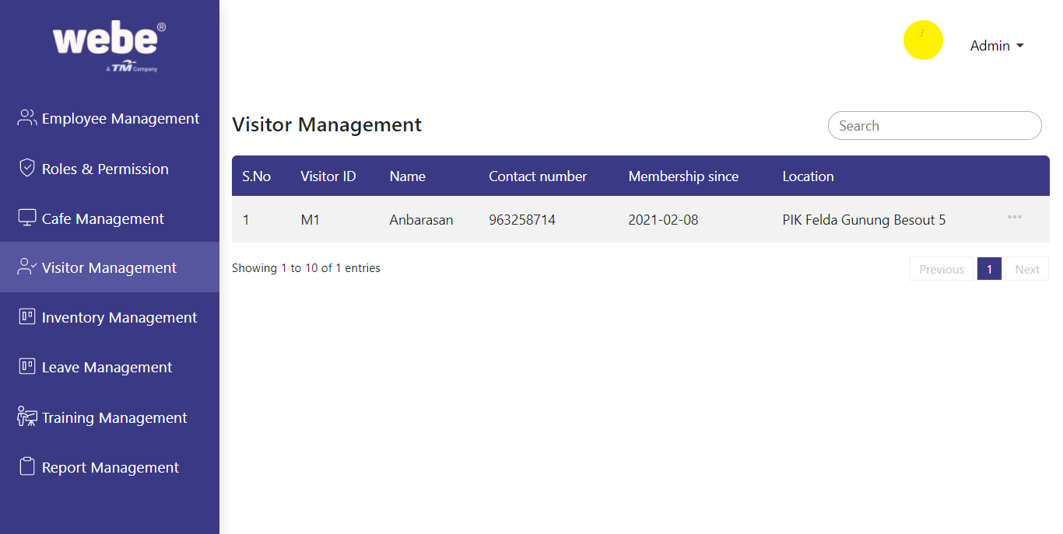

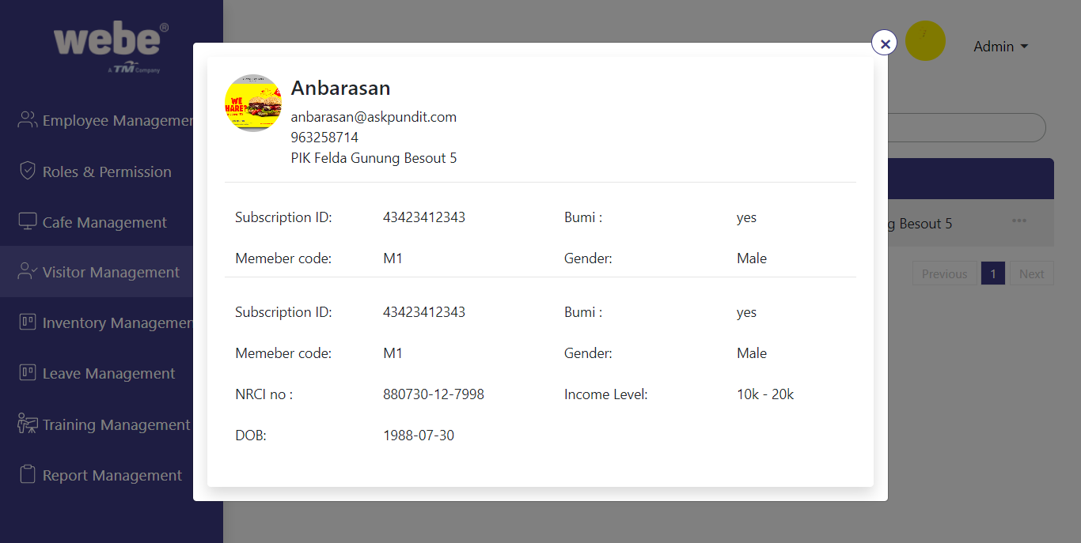

# Inventory Management

Created Inventory system details are available in this section.

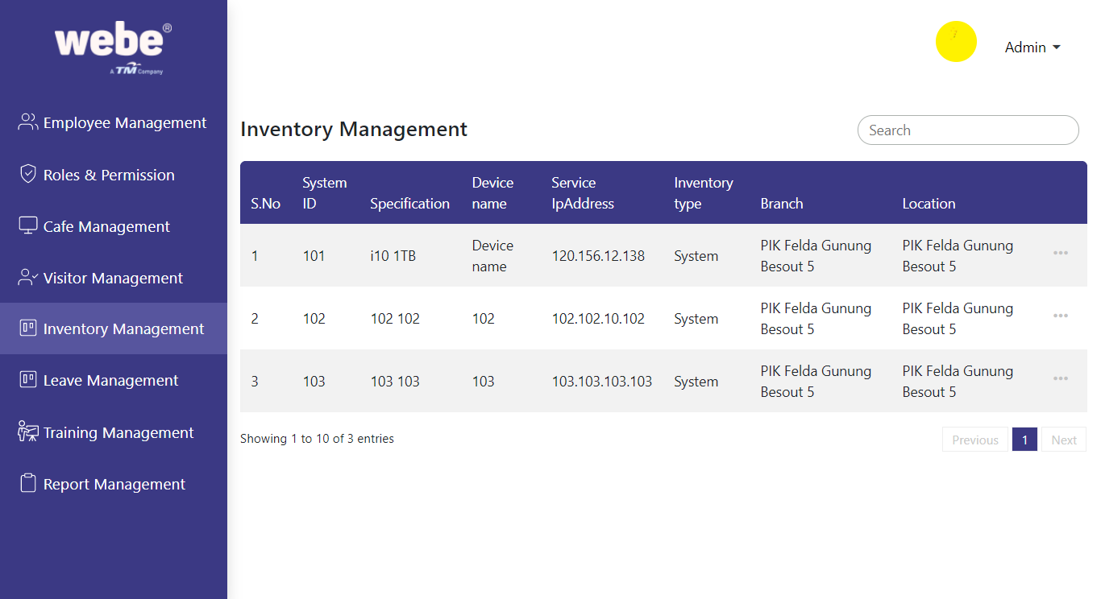

# Leave Management

The employee leave list is available in this section. The employee can request leave in cms and approved in the Leave management section.

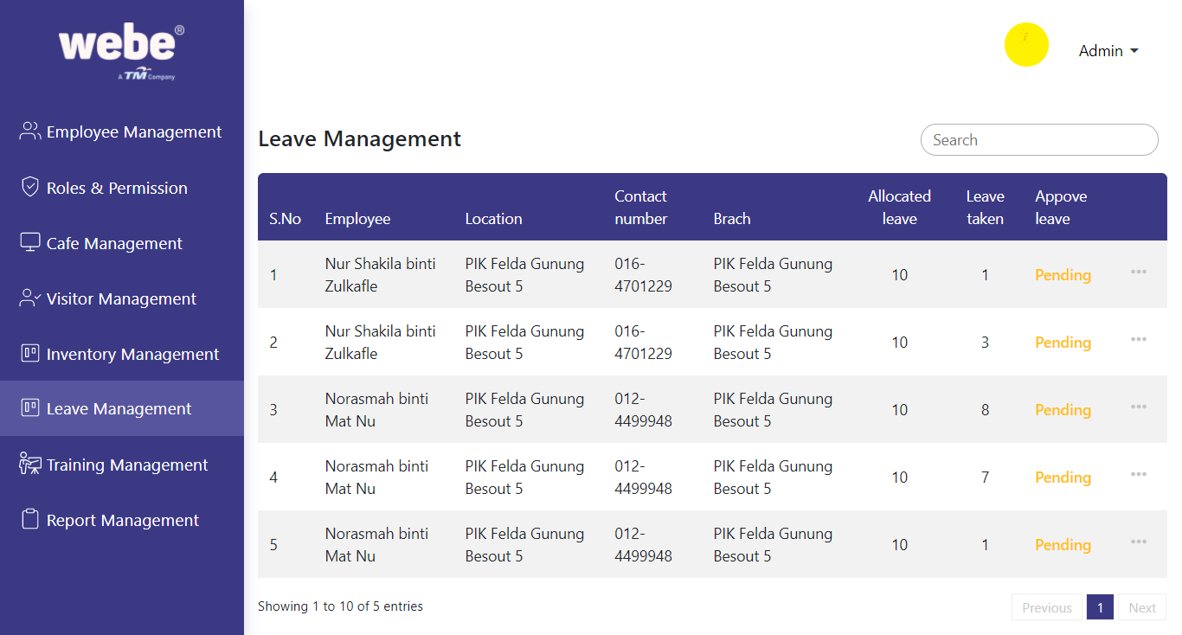

By clicking on the approve button the leave application gets approved.

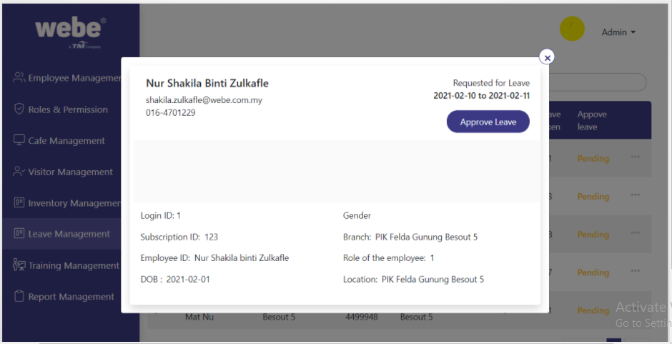

# Training management

The training and course are created in cms and managed in this training management section. We can view the details by clicking on the dot button. 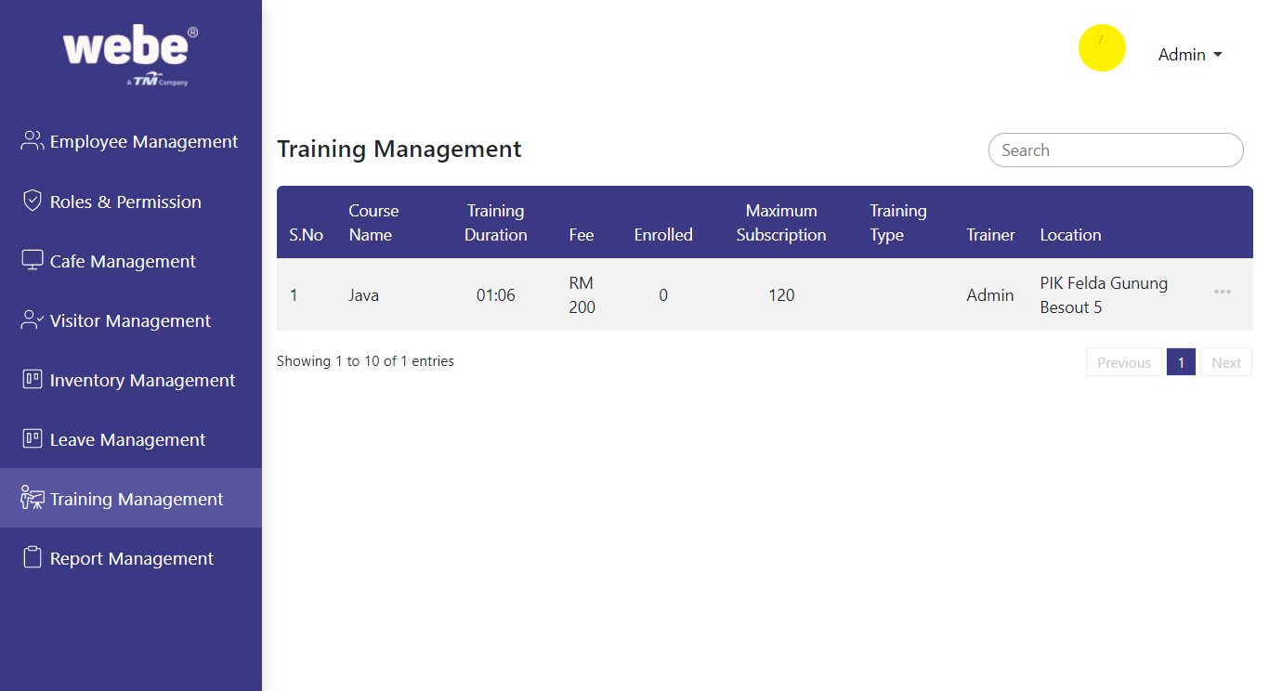

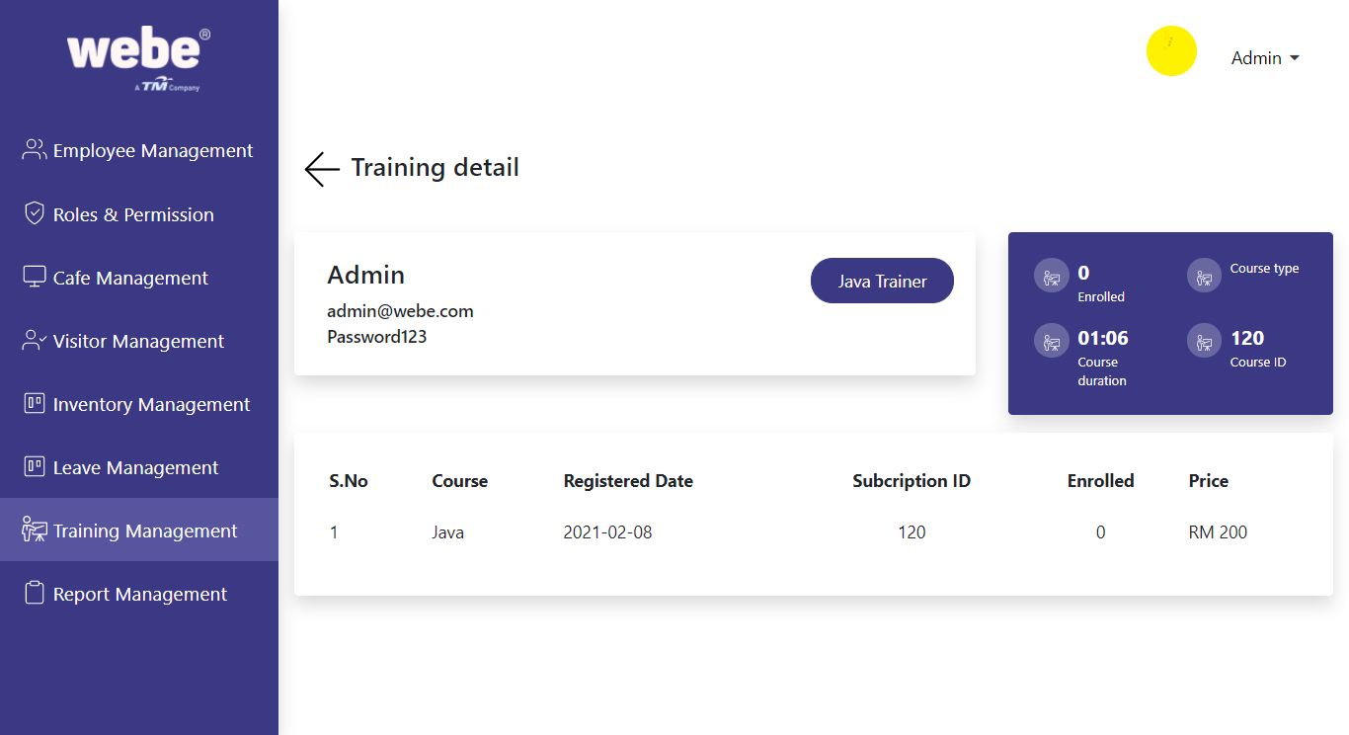

# Report management

In report management we can monitor the cafe performance and their productivity details by choosing the options in the dropdown.

